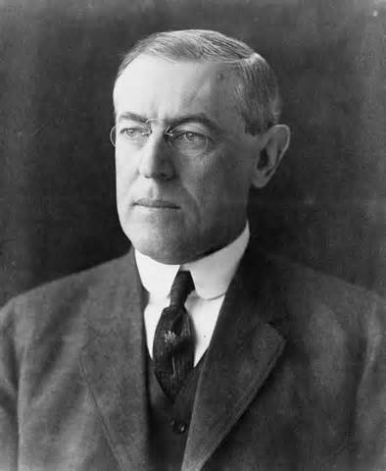
Woodrow Wilson’s Domestic Policy

Answer the following questions in complete sentences.

- How were Theodore Roosevelt and Woodrow Wilson similar as presidents? How were they different?

- What was the name of Woodrow Wilson’s domestic policy, and what was its goal?

- Which two anti-trust laws were passed under Wilson, and what was the function and significance of each?

- How did Wilson view tariffs, and what steps did he take to address taxes?

- Why was the Federal Reserve created? Is it still in use today?

- Were women able to vote prior to the passage of the 19th amendment?

- Who were some of the supporters of women’s suffrage? What happened to these women as they worked for more rights?

- How did President Wilson address civil rights issues?

- What causes the Progressive Era to come to an end?

