

Muckrakers

What is it?



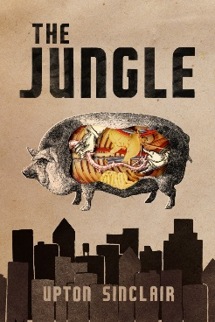

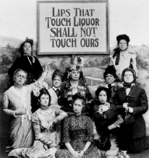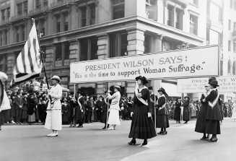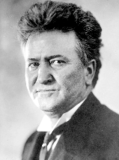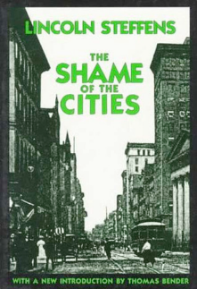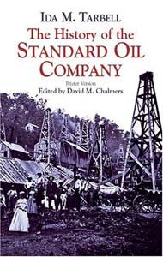

Progressive Era Amendments

**16th Amendment**

**17th Amendment**

**18th Amendment**

**19th Amendment**

**Acronym??**

Types of Progressivism

**Efficiency Progressivism**

**Democratic Progressivism**

**Big Business Progressivism**

**Social Welfare Progressivism**

**The Progressive Era**