Johnson in the Vietnam War, 1963-1969
Bell Work
- Which two countries controlled Vietnam from the year 1900 to 1954?

- What was the purpose of the Geneva Accords?

- Who is Ho Chi Minh, and what does he believe in?

- Why did Presidents Eisenhower and Kennedy send aid to South Vietnam from 1954-1963?

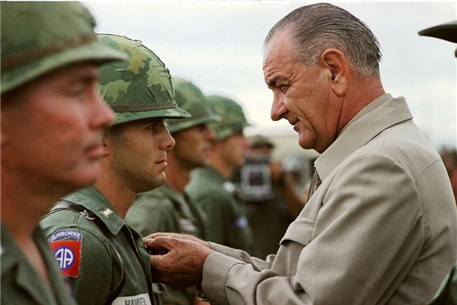

What is Johnson’s attitude towards the Vietnam War at the start of his presidency?

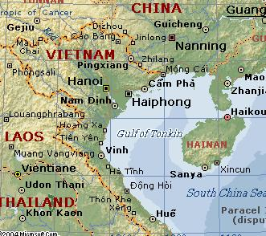

What happens in the Gulf of Tonkin in 1964? What is the immediate and long-term result of this event?

Vietcong Strategy in the Vietnam War | American Strategy in the Vietnam War
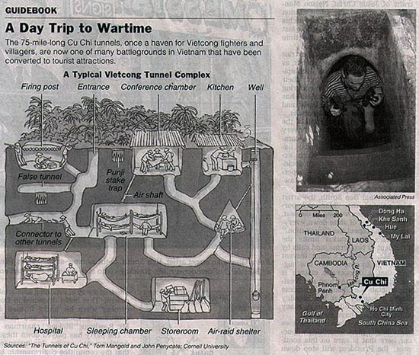
What happens during the Tet Offensive in 1968? Why is this significant for the war?

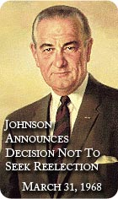
Why does President Johnson choose not to run for re-election in 1968?

What else happens in 1968 that makes it a tumultuous year?

Looking forward….Who will be the next president, and what will his plan for Vietnam be?

