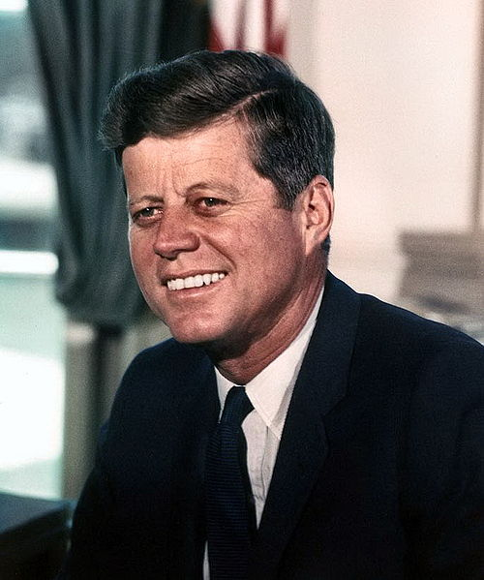
John F. Kennedy as President, 1961-1963

Characteristics
- Young, charismatic, beautiful wife, Catholic
- Wins Election of 1960: saw TV debate with Nixon
- Democrat: help people (poor, elderly, minorities)
- Assassinated in November 1963
- “Ask not what your country can do for you—ask what you can do for your country.”

Domestic Policy |  | Foreign Policy
Program | Was it successful? | Program | Was it successful
New Frontier-programs to help minorities, the poor, the sick, the elderly | NO-most of programs blocked in Congress | Flexible response-increasing size of military/troops (creates elite-Green Berets) | YES-keeps us out of nuclear war
Deficit spending-spends $ on military, help unemployed, poor, funds NASA | YES-it helps people  NO-he spends a lot of money | Alliance for Progress-send $ to Latin America (deter communism) | YES-helps some countries, not all countries use money wisely
Women’s rights-passes Equal Pay Act, tries to help women | Mostly | Peace Corps-volunteer humanitarian organization | YES-around today, known for good humanitarian work
 | First person in space is Soviet Yuri Gagarin 1961  Americans-Alan Shepard and John Glenn | Space Race/Apollo Project-  JFK announces plans to go to the moon | YES-perception that US won the space race, because we got the first man on the moon in 1969 (Neil Armstrong, Buzz Aldrin, Michael Collins)
 | Fidel Castro in Cuba (communist) | Bay of Pigs Incident-  March 1960-CIA invasion of Cuba to overthrow Castro-failures | NO-big failure, we are not able to overthrow Castro-the US and Kennedy looks bad
 | 1961 Berlin Wall built to keep the East Germans from escaping into freedom of West Berlin. | Cuban Missile Crisis-October 1962-Soviets send missiles to Cuba. Kennedy stands up to Soviet Union-we will attack Soviet Union is missiles are launched. After 6 days, Soviets remove missiles from Cuba | YES-Kennedy looks amazing, great leader. Khrushchev falls out of power, is humiliated.

