**Industrialization in the Late 1800s**

**Big Business**

**Labor Unions**

**Why does it occur?**

**Railroads**

For the first time, people form their own businesses and become very wealthy.

* Laissez-faire:
* Social Darwinism:

Horizontal integration

Vertical integration

Monopolies & Trusts

What is it like to work in factories?

Pacific Railway Act









**Industrialization leads to…**

**More railroads lead to…**

**Poor working conditions lead to…**

**Big business lead to…**

**Robber Barons or Captains of Industry?**

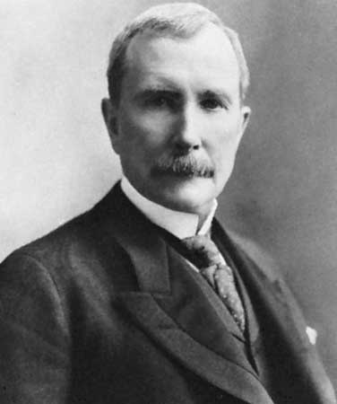

In the late 1800s, entrepreneurs became very wealthy for the first time. There is a controversy over whether these big business owners are robber barons (ruthless leaders who break laws and manipulate workers to maximize their profits) or captains of industry (smart, cunning, and creative men who lead the way in innovation and pioneer industry). Here are some examples.

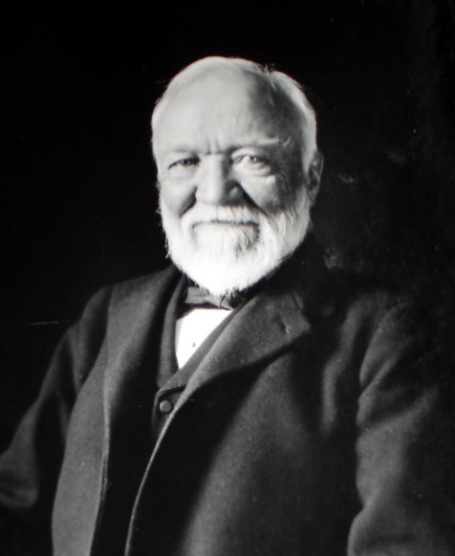

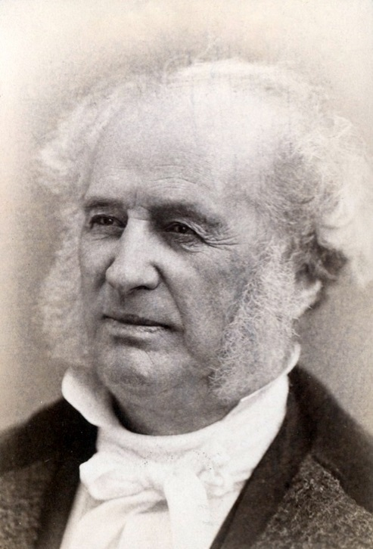

**Andrew Carnegie**

* Scottish immigrant
* Founded United States Steel Co. (monopoly)
* Used vertical and horizontal integration
* Philanthropist who used his fortune to help people
* Authored *The Gospel of Wealth* in which he describes his belief in the Social Gospel

**Cornelius Vanderbilt**

* Railroad consolidator in the Northeast
* Founded New York Central Railroad
* Known for shrewd business tactics, including putting other railroad owners out of business

**John D. Rockefeller**

* Founded Standard Oil Co. (monopoly that was dissolved by the Supreme Court in 1911)
* Used vertical and horizontal integration
* Ruthless: Lowered oil prices to put competitors out of business and THEN raised oil prices after achieving monopoly
* Believed in Social Darwinism