The History of Vietnam & How American Gets Involved in Vietnam
What’s it like in Vietnam?

Vietnam as a French Colony

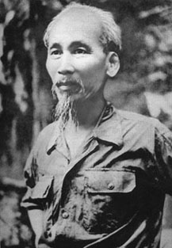
Ho Chi Minh & Vietnamese Nationalism

What does America do to help Ho Chi Minh
fight off the Japanese during World War II?

What happens when the French want to reclaim
Vietnam after World War II ends?

What do both Truman and Eisenhower do in regards to the French-Vietnamese conflict after WWII, and why?
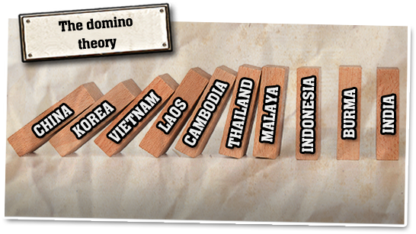

End of the French Indochina War

Geneva Accords 1954

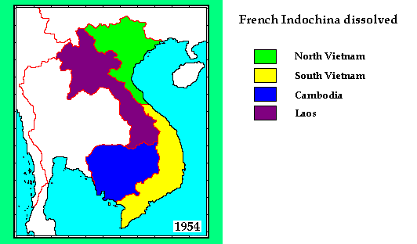
Ho Chi Minh & the Vietcong

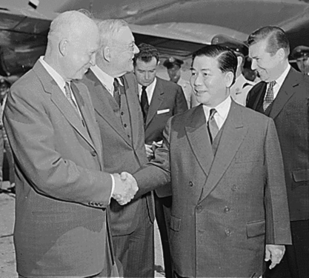
What does Kennedy do in Vietnam?

What happens to Ngo Dinh Diem? Why does he lose support in South Vietnam?

