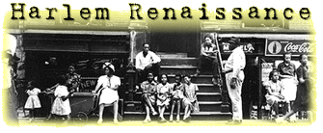
Background: In the 1910s and 1920s, thousands of African Americans move from Southern rural areas to Northern cities in what is called the Great Migration. Some of the reasons for this movement include harsh discrimination and segregation in the South, economic opportunities in Northern cities, and a desire for a better life. Thus, the population of African Americans in Northern cities increased. Many African Americans were concentrated in one neighborhood of New York, called Harlem.

Definition: The flowering of African Americans arts in the 1920s. Harlem was the heart and soul of the African American renaissance, and the environment stimulated artistic development, racial pride, a sense of community, and political organization.

Notable Individuals Associated with the Harlem Renaissance:
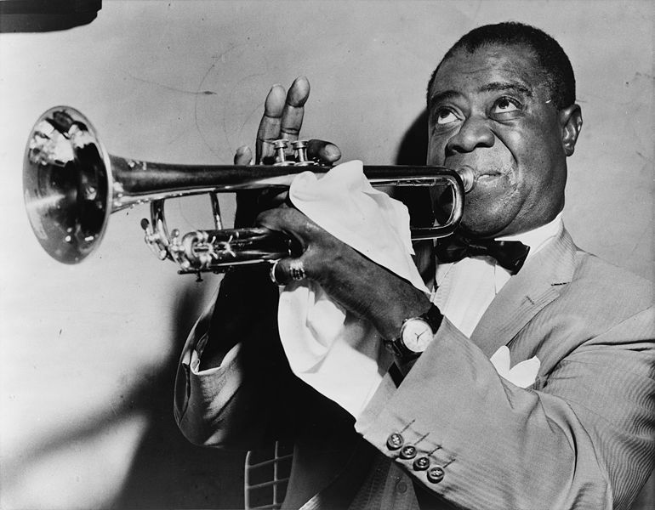
- Claude McKay-writer
- Langston Hughes-poet
- Zora Neale Hurston-novelist
- Louis Armstrong-jazz musician
- Duke Ellington-ragtime musician
- Bessie Smith-“blues” musician
- Paul Robeson-singer/actor
- Josephine Baker-actress and dancer

African American Politics
The racial pride of the Harlem Renaissance contributed to political and economic advances for African Americans. As a result of the Great Migration, African Americans formed a powerful voting bloc which influenced local elections and helped elect African Americans to Congress. W.E.B. DuBois and the NAACP continued to fight against lynchings and discrimination, with little victories. However, some African Americans began to emphasize black nationalism, black pride, and black separation from white society.

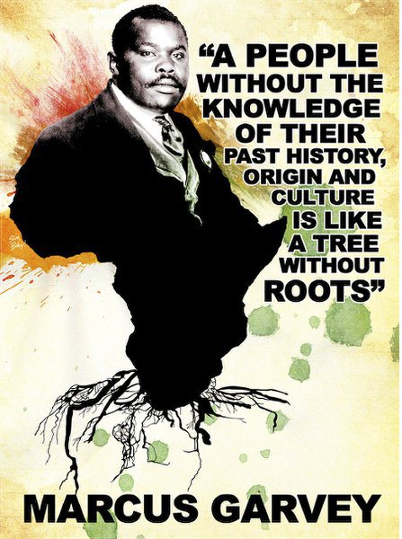
Black Nationalism and Marcus Garvey
Marcus Garvey was a leader from Jamaica who glorified black culture and traditions. He called his ideas “Black Nationalism” and formed the Universal Negro Improvement Association to promote black pride and unity. The message of his Harlem-based movement was that African Americans could gain economic and political power by educating themselves. He also called for separation and independence from whites. In 1920, he presided over a conference in Harlem where he declared that justice would never be found in America and proposed a migration back to Africa. As his ideas became more radical, he alienated himself from other intellectuals of the Harlem Renaissance and began to lose followers. He was convicted of mail fraud in 1923 and deported. Although Garvey was unsuccessful with his movement, the sense of pride and hope among African Americans survived and reemerged strongly during the Civil Rights Era of the 1960s.

