Station 1

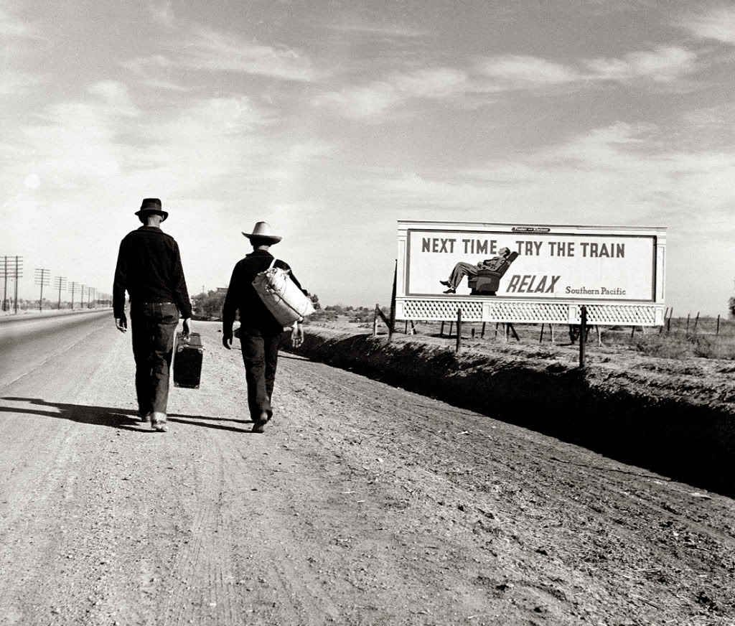Photo A-Dorothea Lange

Station 1

Photo B-Dorothea Lange

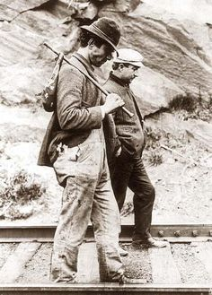

Station 2

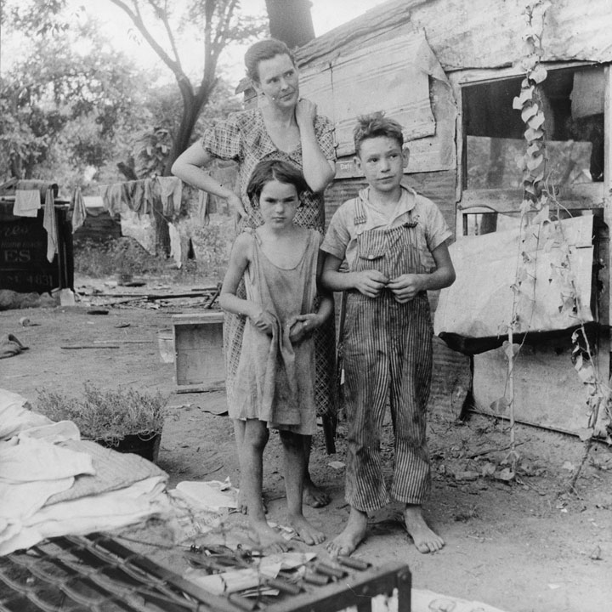Photo A

Station 2

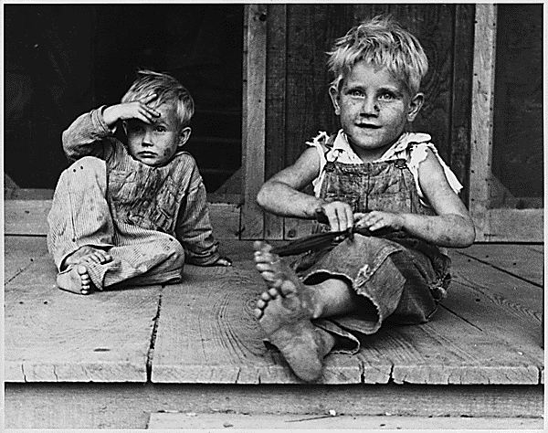Photo B

Station 2

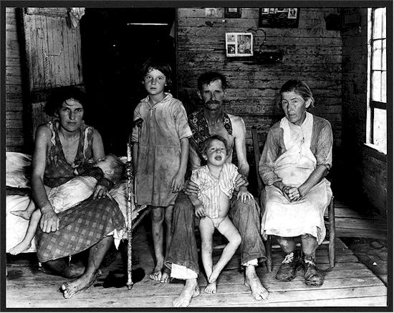Photo C

Station 3

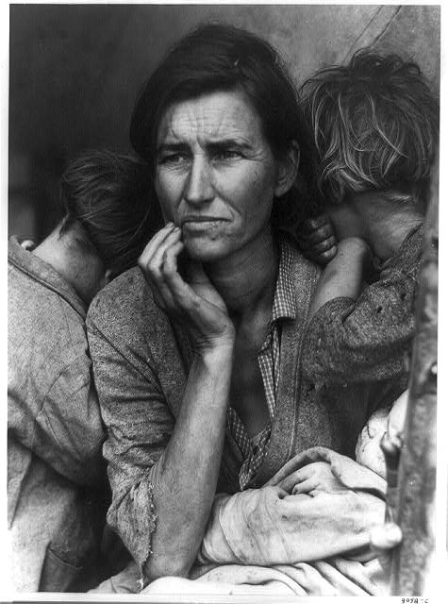Photo A-Dorothea Lange

Station 3

Photo B-Dorothea Lange

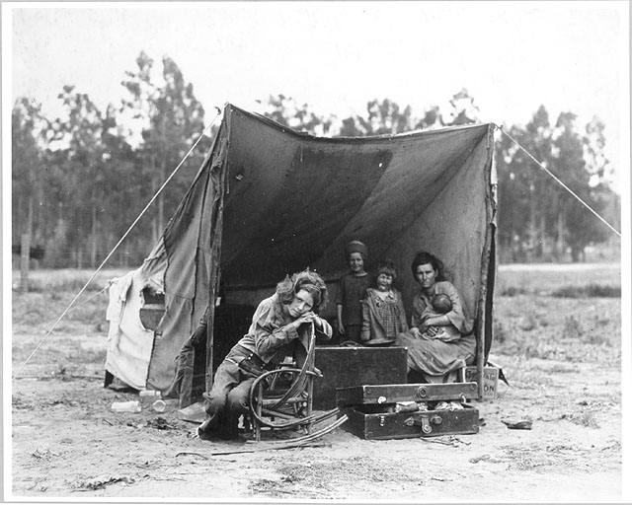

Station 4

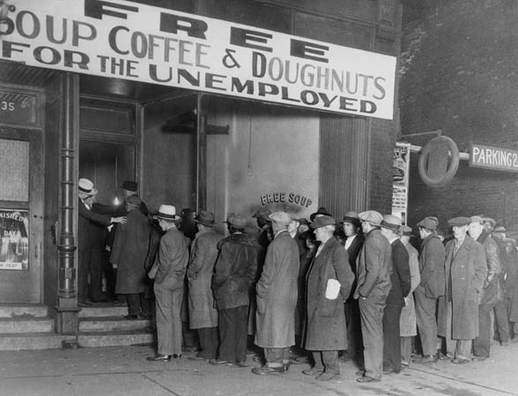Photo A

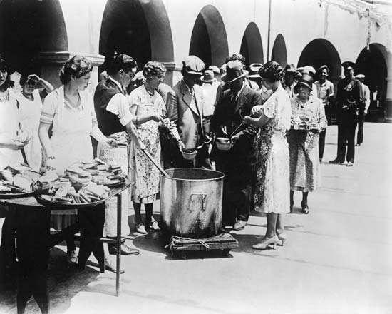Station 4

Photo B

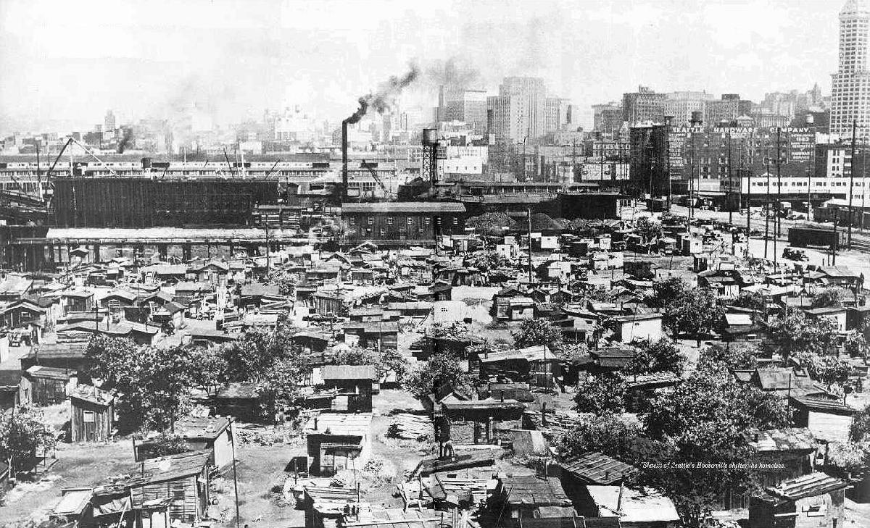

Station 6

[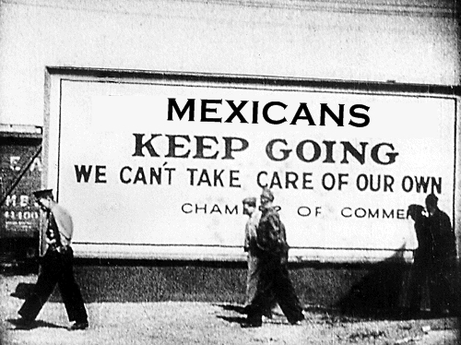](http://latinosreadytovote.com/wp-content/uploads/2012/07/1BA1C95BF24244279F4AE662847FA681.jpg)

Photo A

Station 6

Photo B

[](https://www.google.com/url?sa=i&rct=j&q=&esrc=s&source=images&cd=&cad=rja&uact=8&ved=0ahUKEwiZupjl86HKAhWLbD4KHUycBwQQjRwIBw&url=https://www.pinterest.com/pin/62206038575622069/&psig=AFQjCNFBv_an1xVl_hPbq6P9ppDSQsCfIw&ust=1452606695192988)

[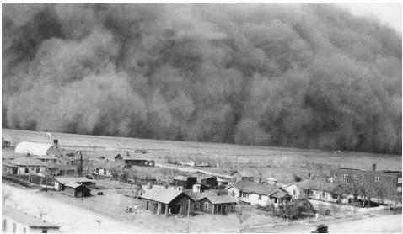](http://www.google.com/url?sa=i&rct=j&q=&esrc=s&source=images&cd=&cad=rja&uact=8&ved=0ahUKEwidzryT9KHKAhWLHD4KHSWbAA0QjRwIBw&url=http://ic.galegroup.com/ic/uhic/ReferenceDetailsPage/DocumentToolsPortletWindow?displayGroupName%3DReference%26jsid%3Da63cd83de6d3d1aefdf5bfb5985e049e%26action%3D2%26catId%3DGALE|00000000MXIM%26documentId%3DGALE|CX3404500149%26u%3Dmlin_c_montytech%26zid%3D7d7ee0a2552956545db1fe44f14ac200&bvm=bv.111396085,d.cWw&psig=AFQjCNF-vzObsMbbrlyD_BM5UsOyf7KdSg&ust=1452606794394186)

Station 7

Photo A

Station 7

[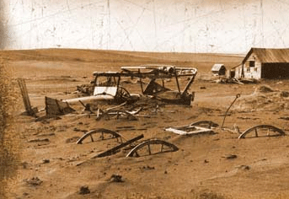](http://www.google.com/url?sa=i&rct=j&q=&esrc=s&source=images&cd=&cad=rja&uact=8&ved=0ahUKEwj1mPmj9KHKAhVGej4KHVBeCwwQjRwIBw&url=http://stuartlhart.com/blog/2011/12/the-new-dust-bowl.html&bvm=bv.111396085,d.cWw&psig=AFQjCNF-vzObsMbbrlyD_BM5UsOyf7KdSg&ust=1452606794394186)Photo B