Ending the Vietnam War

Background: Starting in 1954, Presidents Eisenhower and Kennedy send aid to the government of South Vietnam in hopes of strengthening democracy in South Vietnam and preventing the spread of communism into Southeast Asia. As the government in South Vietnam became corrupt and weak and the Vietcong began attacking cities in the South, President Johnson sent in American troops to defend South Vietnam and began to launch air strikes against the North. The war escalated under Johnson, and although the majority of Americans supported the war in 1965, public opinion had changed by 1969.

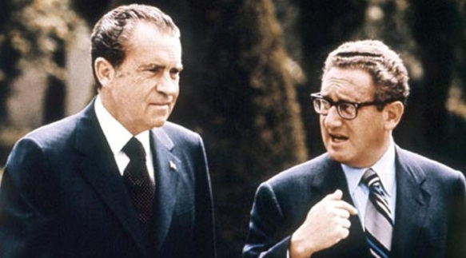
American Reaction to the War
Ways that Americans Protested the War | Reasons for Protesting the War

Vietnam War Under Nixon (1969-1974)
Jan. 27, 1973
April 30, 1975
March 1975
1971
May 1970
April 1970
1969
1968

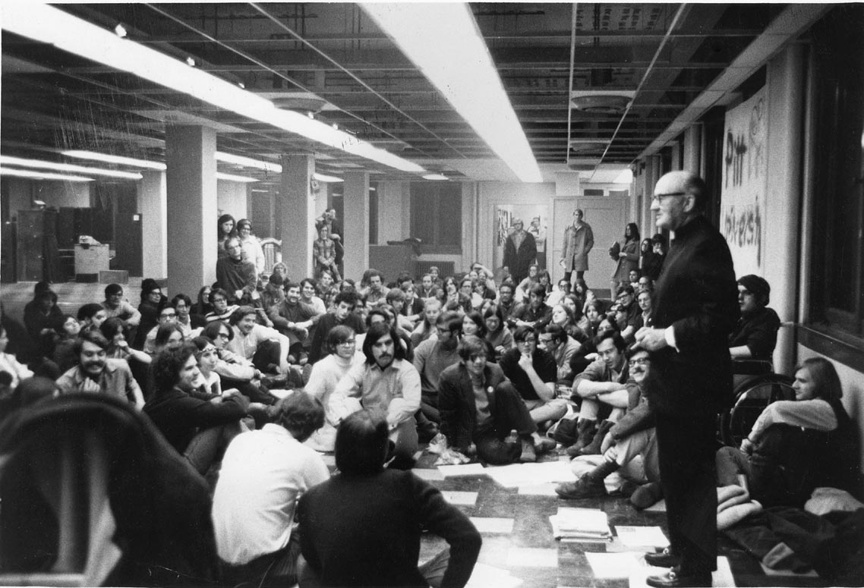
Legacy of the Vietnam War

Teach-ins at a College
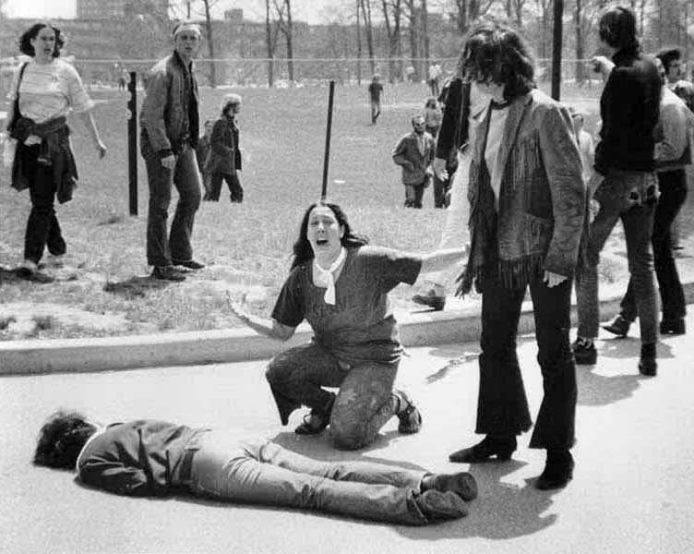
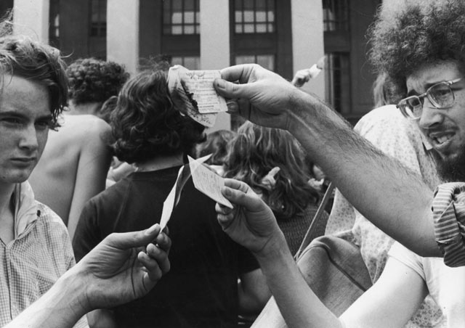
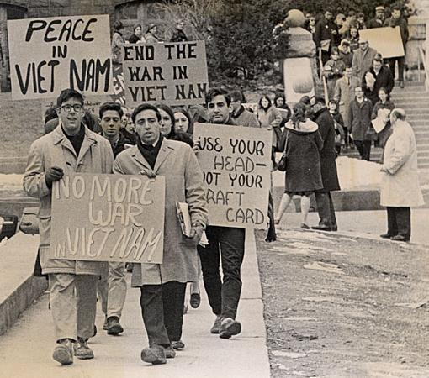
Burning draft cards
Kent State Massacre
Protesting the war

