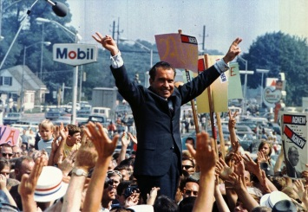
The 1970s
Issues Under Rep. President Richard Nixon (1969-1974):
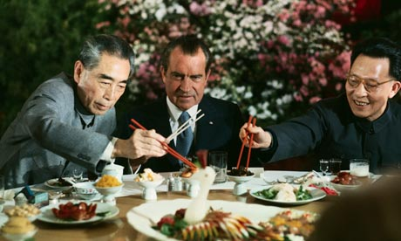
- Environmentalism (EPA, Endangered Species Act)
- Détente (ex. signing of SALT I which limits arms manufactured in USSR and US)
- Positive relations with China
- Watergate scandal—resignation in 1974
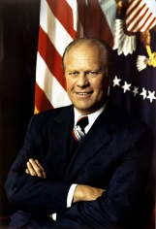
Issues Under Rep. President Gerald Ford (1974-1977):
- Energy crisis due to OPEC embargo—does
not solve
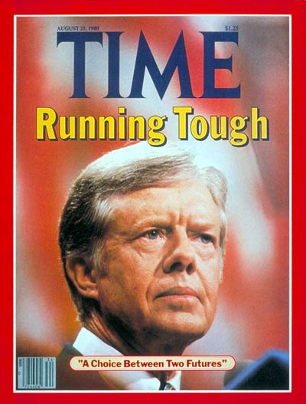
- Failure of détente

Issues Under Dem. President Jimmy Carter (1977-1981):
- Energy crisis—does not solve
- Support for human rights
- Camp David Accords: first step to peace in the Middle East
- Iran Hostage Crisis: 1979-Ayatollah stages a coup in Iran; takes Americans hostage at the embassy in Iran b/c American supports the dethroned shah—hostages are not released until Reagan is elected in 1881
The 1980s

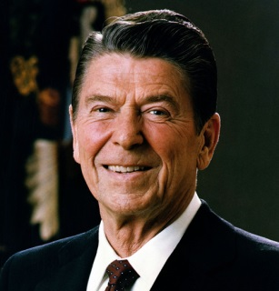
Issues Under Rep. President Ronald Reagan (1981-1989):
- Solves energy crisis
- Appoints Sandra Day O’Conner as first female Supreme Court justice
- Reaganomics (supply side or trickle-down economics): government budget cuts and tax cuts
- Peace Through Strength: Reagan increased defense spending to scare the Soviet Union=works
- Iran Contra Affair: in 1983, 7 Americans are taken hostage in Lebanon by pro-Iranian terrorist groups; Reagan tells American companies not to sell weapons to Iran; Reagan administration violates this rule by selling weapons to Iran in exchange for the release of the hostages; money from the weapon sales is sent to American-supported contras in Nicaragua who are fighting against a communist government; breaks law and Reagan’s staff members are indicted
- Marines in Lebanon: in 1983, a group of peace-keeping Marines in Lebanon are bombed by terrorists, Reagan pulls the Marines out of Lebanon
- The Soviet Union collapses in 1989 (end of Cold War) due to unstable economy and the Berlin Wall comes down in 1991
Themes of the 1980s
- Rise of Conservativism (oppose affirmative action/entitlement programs, support big business, support Christianity, support traditional values, oppose abortion, oppose ERA, reduce spending)
  - Heritage Foundation: conservative think tank that supports Reagan and his policies
  - Moral Majority: organization of fundamentalist and evangelical Christians that support traditional family values and vote Republican
    - Billy Graham: Christian televangelist
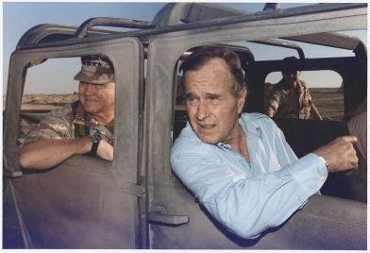
Issues Under Rep. President George H. W. Bush (1989-1993)
The 1990s
- Persian Gulf War: Iraq had accumulated debt from fighting Iran in the 1980s. Iraq’s leader Saddam Hussein ordered an invasion of Kuwait (which had oil reserves) in 1990 and potentially Saudi Arabia (also lots of oil). President Bush ordered Operation Desert Storm to liberate Kuwait, which was successful in 1991.
- Weak economy and high taxes leads to low approval rate

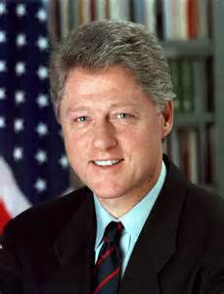
Issues Under Dem. President Bill Clinton (1993-2001)
- Turned federal deficit into a surplus
- Supported Brady Bill (gun control law) which is opposed by the National Rifle Association
- Impeached by House but not convicted by Senate after committing perjury regarding his affair with an intern
- Balkans Crisis: Yugoslavia broke up into 5 nations after the Cold War ended. Some Serbs committed genocide in Bosnia (one of the 5 nations). The US sent troops with NATO to the region to stop the fighting and keep the peace.
- Signed North American Free Trade Agreement (NAFTA) which promotes free trade between Canada, US and Mexico=results in increased trade between these nations
- Signed General Agreement on Tariffs and Trade (GATT) in 1994 to lower trade barriers with other countries
- Wife Hillary Clinton eventually elected to Senate, worked to bring healthcare to Americans as First Lady
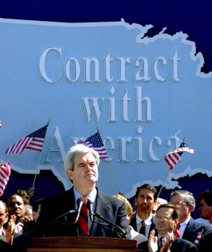
Other Issues
- In 1994, Republicans seize control of both houses of Congress. Their leader is conservative Republican Newt Gingrich who authors the document Contract with America, which lists 10 items from the Heritage Foundation that the Republicans promise to enact into law (ex. tax cuts, tougher crime laws, etc.)
The 2000s

Issues Under Rep. President George W. Bush (2001-2009):
- Election of 2000: George W. Bush versus Democrat Al Gore…Gore won the popular vote, but the Supreme Court determined that Bush won the electoral vote over counting issues in Florida…Ralph Nader ran as third party candidate and split the ticket with Gore (could have led to Gore’s loss)
- September 11, 2001 terrorist attacks occurred; resulted in declaration of a War on Terror and attacks against Osama Bin Laden and the al-Qaeda terrorist network in Afghanistan; war is expanded into Iraq in 2003, resulting in a Second Persian Gulf War
- PATRIOT Act of 2001: gives government power to conduct search and surveillance to protect against future terrorist attacks; seen as violation of civil rights by liberals
- Hurricane Katrina: major hurricane hits New Orleans in 2006 and city floods due to levee failure

Issues Under Dem. President Barack Obama (2009-):
- Election of 2008; results in first African American president
- Great Recession starts in 2009
- Appoints Sonia Sotomayor as first female Hispanic on the Supreme Court
- American Recovery and Reinvestment Act helps provide jobs in light of the Great Recession

Sam Walton-founds Walmart
Estee Lauder-successful entrepreneur (make-up)
Robert Johnson-Harvard graduate who founds BET
Lionel Sosa-Hispanic marketing expert

